

**Amrita School Of Computing**

**5th semester**

**Computer Networks Lab(20cys382)**

**End Semester Project Report**

**IoT** Based **Smart** Home **Automation** using **Cisco Packet Tracer**

**Submitted To**

Dr. B Indira

Assistant Professor

Department of Cyber Security

**Submitted By**

Annadanam Padmasini

Enaganti Karun Kumar

Gummanur Abhishek

Kumoulica Allu

Index

Abstract

01



Introduction

02





03

Methodology

04



Devices used



05

Implementation & output



06

Advantages & Disadvantages

Conclusion

07



**Abstract**

The phrase IoT (internet of things) has grown significantly in importance in today's world. This technology is utilised in a variety of sectors, including infrastructure, industry, agriculture, and the health sector. Many useful learning tools are utilised to teach and comprehend how this technology functions. The purpose of this project is to present a platform for IoT simulation, where students may model, create, and manage systems to better grasp the underlying philosophy of IoT networks. In order to establish and simulate a virtual network—basically, a wireless network without the need for any network gear, Cisco packet tracer is the technology employed.

In this project, a smart house or internet-based home automation system is designed using "Cisco packet tracer."

**Introduction**

In the rapidly developing world of today, technology is constantly being utilised in daily life without becoming a need. The term "smart home" refers to a living space that has smart items with specialised capabilities. Smart homes may be used to automate household tasks without the need for people to constantly check the home environment using various sensors (temperature, humidity, smoke, wind, and sound). Additionally, there are frequently monitoring tools available, and smart mobile devices or internet-connected computers may access the autonomous and controlled equipment. Smart homes may provide a variety of features to give automatic protection utilising different alarm systems, as well as LCD displays, siren sounds, and by sending emails to legitimate users if sensor detects security difficulties rather than secure security.

This report explains how to create a smart home using the most recent version of Cisco Packet Tracer  which offers a variety of sensors, actuators, and intelligent devices for home automation. Some of the gadgets include lighting, windows, fans, and doors with various detectors and sensors. A smart house may be implemented using the most recent version of the simulation tool for Cisco packet tracer modelling and setup of IoE systems with traditional networking system.

**Methodology**

Including a variety of smart devices that are used to implement home automation, including windows, fans, lighting, doors, garbage doors, lawn sprinklers, fire sprinklers, cell towers, stylish webcams, and varied sensors. For controlling linked items and providing control mechanisms through the registration of Home Gateway smart devices, the Microcontroller (MCU-PT) and Home Gateway are employed. They provide a programming environment for controlling connected objects and sensors.

Home gateway: Home Gateway includes four Ethernet connections as well as a wireless access point with the SSID "Home Gateway." On the home gateway, WEP, WPA-PSK, or WPA2 business can be enabled to secure wireless connections.

Micro Controller Board: A microcontroller board is used to link various smart objects and to provide a programming environment using several languages, including Python, Visual Basic, and JavaScript, to operate the connected smart objects.

**Used Device For Design**

|  |  |  |
| --- | --- | --- |
| **S.No** | **Devices** | **Functions** |
| 1. | Home Gateway | Used to assign IP addresses to smart objects and register smart things |
| 2. | MCU | Used to connect different intelligent things |
| 2. | Cable modem | Use to connect to the internet at home |
| 3. | Tablet | Used to control the home from outside |
| 4. | Fan | Used for ventilating the home environment on the basis of certain circumstances |
| 5. | Light Provide light | Provide light |
| 6. | Motion detector | Link to your home getaway and detect motion |
| 7. | Smart door | Link to your home getaway and provide an event based on functions |
| 8. | Lawn sprinkler | Used as a sprinkler based on environmental water level |
| 9. | Smoke sensor | Used to sense the smoke level |
| 10. | Temperature sensor | Used to sense the temperature of the home |
| 11. | Older car | Used to model various home development scenarios as it affects the amount of oil, co2 and smoke. At a level of 1 percent an hour, this absorbs carbon monoxide. At a level of 2 percent an hour, this absorbs carbon dioxide. Affects Smoke at an hourly rate of 3%. |
| 12. | Smart Light | Used to give light for home |
| 13. | Appliance smart coffee maker | Used to make a filter coffee |
| 14. | Solar smart panel | Used to generate power using solar energy |
| 15. | Battery | Saves energy or power for usage |

**Implementation**

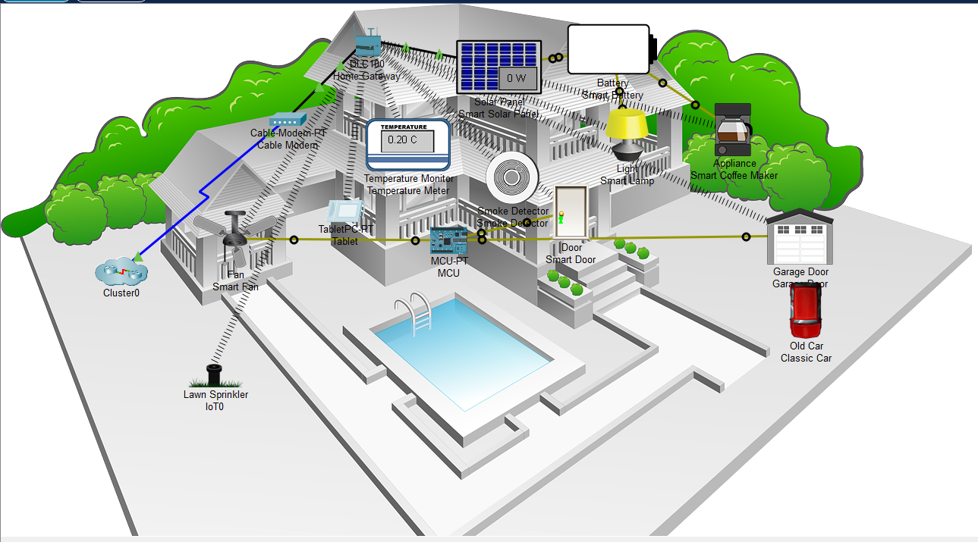

The graphic illustrates how all smart devices may be accessed through the web by authorised users after being registered with the home gateway. The figure depicts eight IoE devices that have been registered to a home gateway and are all legitimately operated through the internet.

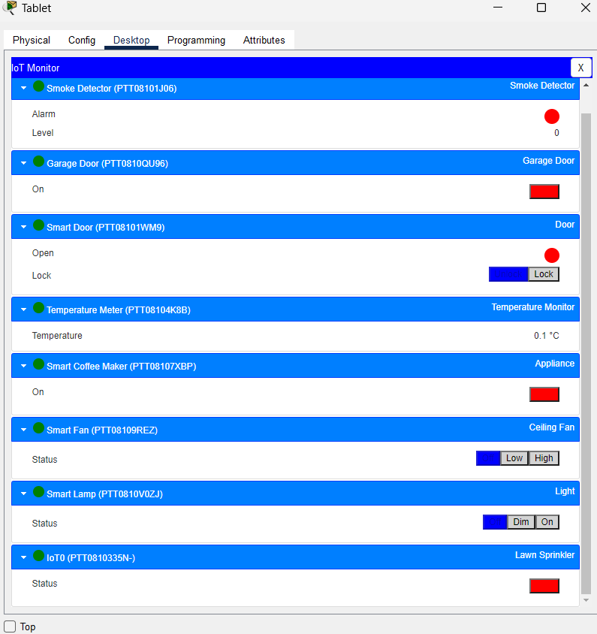

Advantages & Disadvantages

**Pros:**

* **Controlling all of your home technology from a single location:** Here, convenience is a major consideration. A huge advancement in technology and home management is being able to keep everything connected through a single interface.
* **Increasing comfort at home:** When you incorporate security and monitoring functions into your smart home network, your home security might rise.
* **Improved appliance functionality**: Smart homes will also assist you in properly operating your appliances. A smart TV will aid you in conducting better searches across channels and applications to find your preferred programming.

**Cons:**

* **Do not combine your smart home devices**: When there are too many options for smart home accessories, the first problem you can encounter is purchasing the thermostats, security cameras, and alarms that you really want only to discover that they don't work together automatically.
* **Your smart home system is triggered by The Wrong Moments:** Nothing is more annoying than a smart device that constantly demands your attention for the wrong reasons. This is especially true for sophisticated security cameras and sensors.
* **Your smart home system's battery discharges so fast:** When you are aware that wireless systems need maintenance, smart home wireless solutions are excellent. Door sensors and other low-energy items often only need new batteries once or twice a year, whereas cameras and motion sensors gobble up batteries much more quickly. A useless smart home gadget is a dead smart home computer.

Conclusion

We chose the recently released Cisco kit to present smart homes in this article because it included a lot of IOE devices for home automation. We utilised a home gateway to register smart devices and a microcontroller (MCU) to link various sensors and IOE devices in order to monitor them.